**AMIT PROJECT**

NAME: AHMED WAEL AHMED

GROUP: H-23

PROJECT DISCRIPTION

the aim of this project is to build a mini smart home that can be controlled using a Bluetooth module from phone that will send the actions through two connected microcontrollers, then the user will be able to control many devices without any physical interaction. And here in the project the devices that will be controlled are two LED.

PROJECT COMPONENTS

* Atmega32 microcontroller as “U1”.
* Atmega32 microcontroller as “U2”.
* Two LEDs “LED1 and LED2”.
* Two Resistances “R1 and R2”.
* Virtual Terminal VT work as “Bluetooth module”.

**PROJECT SCHEMATIC**

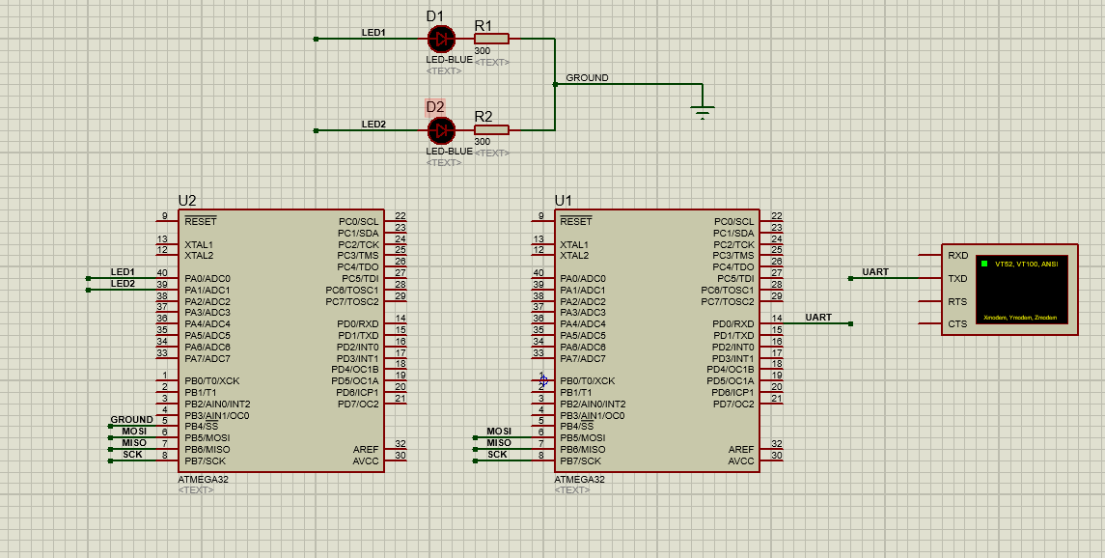

**PROJECT PROCEDURES**

VT in which in our project act as a Bluetooth module that will send data to U1 microcontroller using our phone and then the VT will communicate with U1 microcontroller through USART communication protocol, then U1 microcontroller will pass this data that he gets from VT to U2 micro controller using SPI communication protocol and the U2 microcontroller will controls the LEDS 1 and 2 depending on the command received from U1.

These are the options we can use in our simulation:

Sending 1 will toggle led1.

Sending 2 will toggle led2.